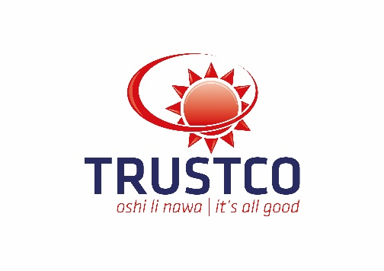

TRUSTCO GROUP HOLDINGS LIMITED
Incorporated in the Republic of Namibia
(Registration number 2003/058)
NSX Share Code: TUC
JSE Share Code: TTO
ISIN Number: NA000A0RF067 ("the Company" or "Trustco”)

Trustco completes major debt financing
Trustco has completed a debt financing of approx. NAD 450 million which has been raised in the private placement market.
The funds raised will be deployed principally in Trustco’s banking and finance segment, through Trustco Bank and Trustco Finance, the Company’s principal lending arms. The funds will be mainly used for small enterprise and individual business loans, as well as microfinance loans for tertiary education.
The financing represents one of the largest ever equity or debt financing by a Namibian-owned and privately-owned (non-government owned) company.
The debt financing programme includes a USD 10 million financing from NORSAD Finance raised at the group level. The balance of the financing denominated in South African Rand, to which the Namibian Dollar is pegged, including an approx. ZAR 115 million amount raised from the European Investment Bank, which will be used specifically for small enterprise and individual business loans to be extended by Trustco Bank. The balance of the funding has been raised from leading international investors.
‘’The Trustco Group remains committed to a vision of creating wealth for our shareholders, customers and employees while impacting positively on society and our planet. This facility will enable Trustco to contribute meaningfully to the aspiring citizens of Namibia, for whom I hold a great affinity to. By providing much needed loans that traditionally have been difficult to obtain, the Group will fully demonstrate its commitment to business and entrepreneurs.” said Dr. Quinton van Rooyen, Group Managing Director of Trustco.
“The European Investment Bank has a strong track record in supporting crucial investment programmes across Africa and around the world.” said Pim van Ballekom, European Investment Bank Vice-President. “We are glad to support Trustco Group Holdings Limited in continuing to provide loans to a crucial segment of the economy that has traditionally struggled with getting access to finance.”
Verdant Capital acted as financial advisors and arrangers to Trustco with respect to the debt private placement.
About Trustco: Trustco is a Namibian-based company with a focus on financial services, especially insurance, microfinance for education, Micro and SME Financing and mortgages, property, education and resources. Trustco has a dual listing on the main board of the JSE and the Namibian Stock Exchange.
About Norsad Finance Limited: Norsad Finance Limited is a Southern African impact investor with strong Nordic roots. Norsad Finance provides long-term investment loans and risk capital to financially, socially and environmentally sustainable projects and companies.

About EIB: is the long-term lending institution of the European Union owned by its Member States. It makes long-term finance available for sound investment in order to contribute towards EU policy goals. The EIB has provided projects in Namibia with lending on favourable terms totalling EUR 294,5 million ever since the first operation in the country in 1992. Last year alone, it provided more than EUR 2,1 billion for investment across Africa.
Windhoek, Namibia
November 2, 2016
Amanda Bruyns
Company Secretary: Trustco Group Holdings Limited
Corporate advisor and JSE Sponsor: Sasfin Capital (A division of Sasfin Bank Limited)
NSX Sponsor: Simonis Storm Securities (Pty) Ltd

